Repealing the ACA: Effects on Counties

Speaker Bios

Farrah McDaid Ting
Legislative Representative
California State Association of Counties

Farrah McDaid Ting serves as the Legislative Representative for Health and Human Services with the California State Association of Counties (CSAC).

She specializes in California health and human services programs that are administered by counties or have an impact on counties, and has done so since 2007. Prior to 2007, Farrah served as a CSAC legislative analyst on a variety of issues, including employee relations, agriculture and natural resources, transportation and housing, and Indian gaming issues.

She began her county career at CSAC in 2001, serving on the Public Affairs side of the organization as a communications analyst. Before coming to CSAC, Farrah was an assistant editor at the California Journal, a nonpartisan government and politics-focused monthly magazine in Sacramento.

Farrah earned a Bachelor’s degree in Government/Journalism and graduated cum laude from California State University, Sacramento in 1999. She lives in Sacramento with her husband and two young children and enjoys traveling to counties throughout the Golden State.
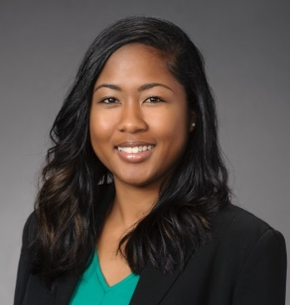
Michelle Gibbons
Executive Director
County Health Executives Association of California

Michelle Gibbons is the Executive Director for the County Health Executives Association of California (CHEAC).

Prior to her role at CHEAC, Ms. Gibbons served as the health and human services legislative analyst for the California State Association of Counties as well as various roles within the California Department of Health Care Services.

CHEAC is a statewide organization of county Health Department and Agency Directors, who are responsible for the administration, oversight, and delivery of a broad range of local public health and indigent health care services. CHEAC is an affiliate of the California State Association of Counties (CSAC).

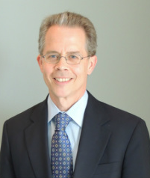
Tom Joseph
Vice President and Managing Partner
Waterman & Associates

Tom Joseph is vice president and managing partner of Waterman & Associates and heads up the firm's health and human services practice. Tom has represented county interests in Washington, DC for over 30 years, including advocating for CSAC’s federal health and human services priorities for the past 12 years.

Before his work at Waterman & Associates, Tom served over 16 years with the National Association of Counties (NACo) and was deputy director of their legislative department, overseeing its overall policy process. He provided policy direction and briefed elected officials serving on NACo’s Health and Human Services Steering Committees, as well as professional affiliates of county department heads responsible for administering health and human services programs.

Los Angeles County recruited Tom in 2005 to help establish a full-time Washington office for them. He worked seven years as one of their chief lobbyists on health and human services issues.

Tom holds a Master of Public Policy degree from Duke University and a Bachelor of Arts degree in psychology from St. Olaf College in Minnesota.

